Unit Test Results Template
Use this template to capture unit test evidence. Paste a screenshot into the “Screenshot / Evidence” cell for each unit test case (Insert > Pictures or paste directly).
Test Case Name | Screenshot / Evidence
TC-TR-01a: Template inserted and retrieved by ID
TC-TR-01b: Non-existent ID returns None
TC-TR-02a: exists() returns True for inserted template
TC-TR-02b: exists() returns False for missing template
TC-TR-03a: list_all() excludes soft-deleted by default
TC-TR-03b: list_all(active_only=False) includes archived
TC-TR-04a: update() changes name field
TC-TR-04b: update() with unknown ID returns False
TC-TR-05a: soft_delete() sets is_active=0
TC-TR-05b: soft_delete() on missing ID returns False
TC-TR-06a: hard_delete() removes record permanently
TC-TR-07a: Only one template can be default at a time
TC-TR-08a: get_default() returns explicitly marked template
TC-TR-08b: get_default() returns None on empty DB
TC-TR-09a: Inserting with is_default=True clears previous
TC-TRT-01a: GET /templates returns 200 and list
TC-TRT-01b: include_archived param passes active_only=False
TC-TRT-02a: GET /templates/{id} returns 200
TC-TRT-02b: GET /templates/{id} returns 404 for missing
TC-TRT-03a: POST /templates with valid docx returns 200
TC-TRT-03b: POST /templates with empty filename returns 422
TC-TRT-03c: POST /templates with unsupported type returns 400
TC-TRT-04a: POST /templates/from-text returns 200
TC-TRT-04b: POST /templates/from-text missing name returns 422
TC-TRT-04c: POST /templates/from-text missing content returns 422
TC-TRT-05a: PUT /templates/{id} with valid body returns 200
TC-TRT-05b: PUT /templates/{id} with empty body returns 400
TC-TRT-05c: PUT /templates/{id} for missing template returns 404
TC-TRT-06a: DELETE /templates/{id} returns 204
TC-TRT-06b: DELETE /templates/{id} for missing returns 404
TC-TRT-07a: POST /templates/{id}/set-default returns 200
TC-TRT-07b: POST /templates/{id}/set-default for missing returns 404
TC-TRT-08a: POST /templates/{id}/parse returns 200
TC-TRT-08b: POST /templates/{id}/parse returns 404 when source missing
TC-TRT-09a: GET /templates returns 503 when service not initialised

Screenshot / Evidence
- Template Repository
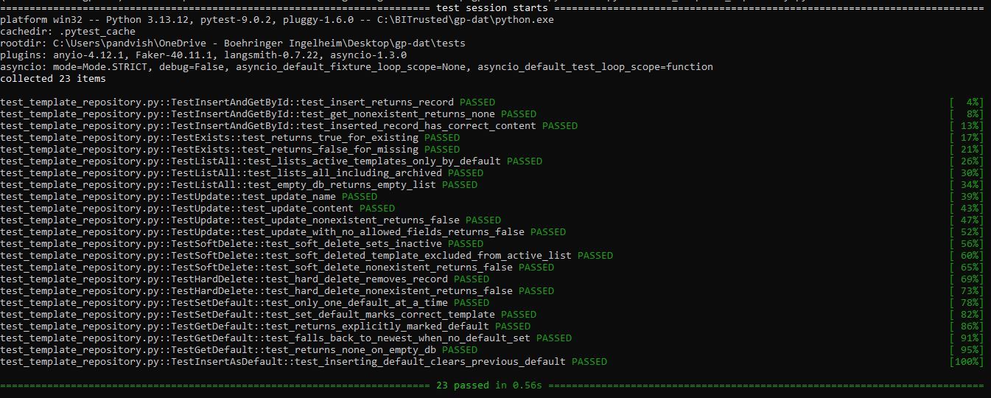

- Template Router
